**CASE STUDY:**

**Library Management System.**

**Use Case Diagram:-**

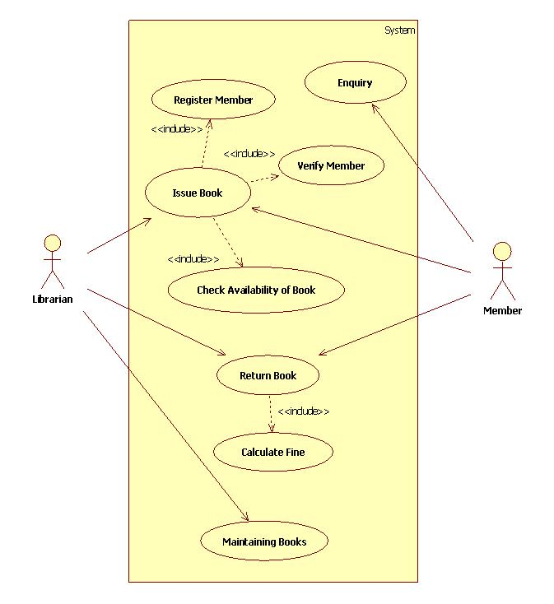

**Activity Diagram for Return Book in Library:-**

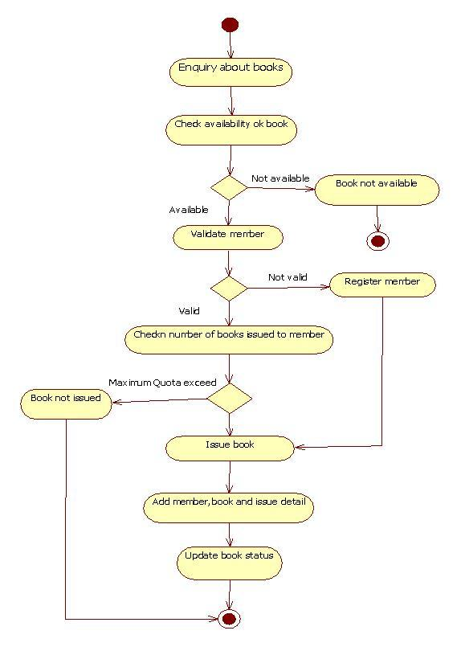

**Class Diagram for Library System:-**

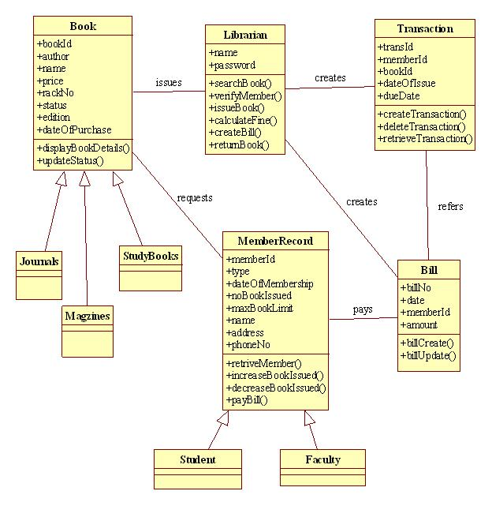

State diagram for Book:

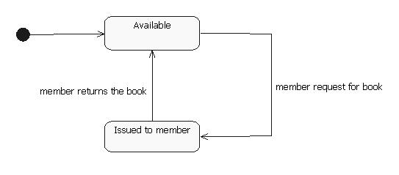

State diagram for Librarian:

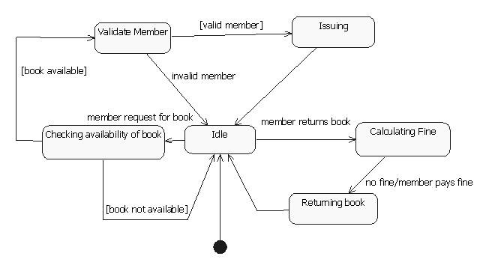

Collaboration diagram for issuing Book:

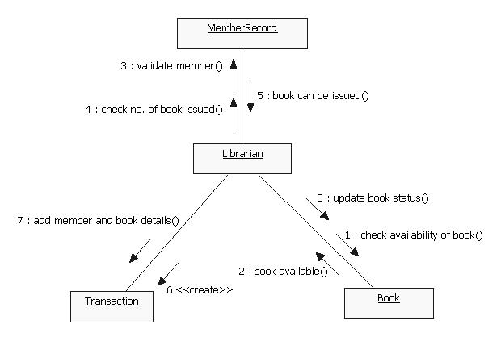

Collaboration diagram for returning Book:

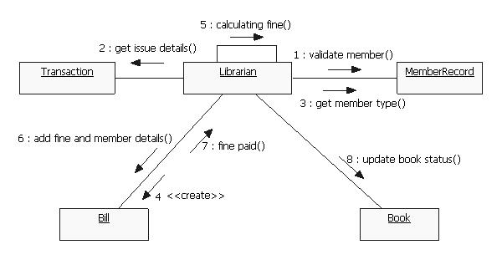

Sequence diagram for issuing book:

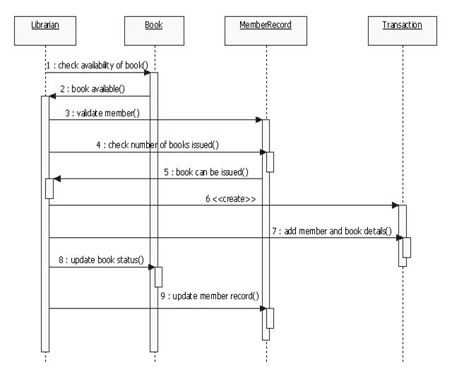

Sequence diagram for returning book:

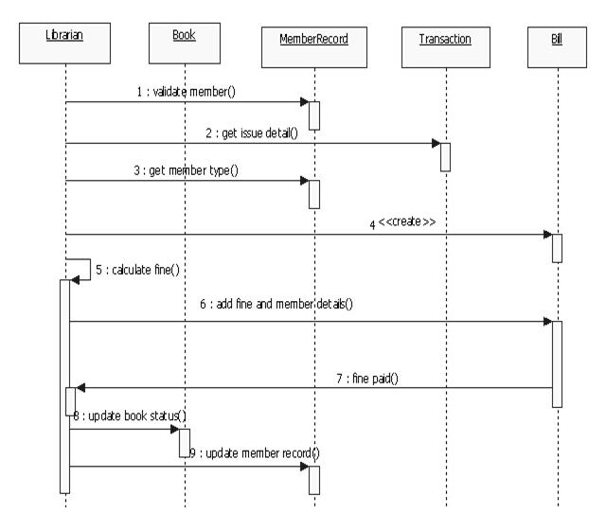

Component diagram for Library Management System:

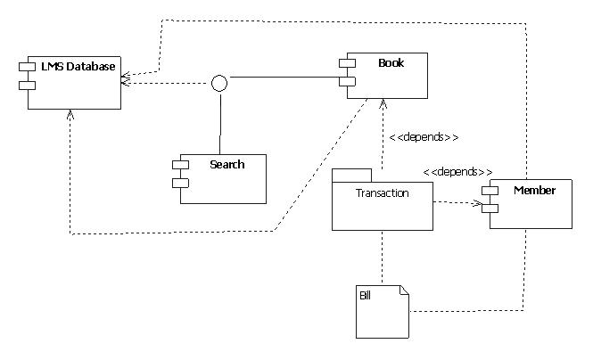

**Deployment Diagram for Library management system:-**

